**Data Mapping for new entities**

|  |  |  |  |  |
| --- | --- | --- | --- | --- |
|  | **Attributes** | **Description** | **Entity** | **Data Type** |
| **Addresses** | **AddressID** | **A unique identifier for each address (PK)** | **Addresses** | **char(10)** |
| Street1 | First line of an address |  | varchar(50) |
| Street2 | Second line of an address |  | varchar(50) |
| City | City of an address |  | varchar(15) |
| State | State of an address |  | varchar(15) |
| Zipcode | Zipcode of an address |  | decimal(5,0) |
| Country | Country of an address |  | varchar(15) |
| POBox | Flags the address as a PO Box |  | Bit |
| Military | Flags the Address as a Military Base |  | Bit |
| **Cards** | **CardID** | **A unique identifier for each card (PK)** | **Cards** | **decimal(16,0)** |
| **AccountID** | **The unique identifier for an account (FK)** | **Account** | **char(10)** |
| SecurityCode | The security code on the card |  | decimal(3,0) |
| Activated | Date the card was activated |  | Date |
| Expires | Date the card expires |  | Date |
| Chip | Flags the Address as a Military Base |  | Bit |

**Create a data model in 3NF**

**Rationalization:**

I choose **Address** as my static entity because I didn’t like how addresses were originally stored in **Client**. Especially since people can live together and share an address, and addresses are unique, they rarely ever change, people just move from one location to another. Doing this will require me to alter my existing **Client** entity. Client will now have two address values, one for a verification address, and another mailing address for the client to receive correspondence.

I choose **Cards** as my dynamic entity because some accounts, but not all accounts, have cards associated with them, like checking, credit card, and sometimes even savings. I’m using AccountID as a FK since no card can exist without an account. Since cards can’t exist without accounts, and accounts can have multiple clients, then using these 2 keys make this unique while still allowing multiple clients to use the same card. The reason why I chose to make it dynamic is because technologies always change, like the addition of the chip in recent years and we don’t know what new technologies will bring tomorrow. We might see a 2 factor authentication method in the future where they pair an app with the card before usage is allowed. Since cards have unique dates, they can’t be integrated with accounts. I didn’t assign addresses to the cards because I would use the addresses from the clients that are attached to the account that the card uses as a forms of authentication means.

**More Sample Data**

Client

|  |  |  |  |  |  |  |  |  |  |
| --- | --- | --- | --- | --- | --- | --- | --- | --- | --- |
| **ClientID** | ClientSSN | | ClientFirstName | | ClientSurname | ClientLastName | | ClientOpenDate | |
| 000000001C | 123456789 | | John | | null | Doe | | 03/02/1993 13:23:14.364 | |
| 000000002C | 987654321 | | Jane | | Smith | Doe | | 01/09/1987 10:43:56.545 | |
| 000000003C | 123498765 | | Miguel | | Ortega | Perez | | 10/23/2007 17:55:32.174 | |
| 000000004C | 987651234 | | Mona | | null | Lisa | | 08/02/1973 15:07:23.217 | |
| 000000005C | 098056440 | | Janis | | null | Ika | | 01/03/2003 10:43:54.048 | |
| ClientCancelDate | | ClientEmail | | ClientPhone | | | ClientAddress | | MailingAddress |
| 07/19/2001 15:34:01.214 | | johndoe@outlook.com | | 2028274812 | | | 000000001D | | 000000001D |
| null | | Null | | 2129205892 | | | 000000001D | | 000000003D |
| null | | ortega@gmail.com | | 9145928279 | | | 000000002D | | 000000002D |
| null | | paintings@yahoo.com | | 6469201857 | | | 000000003D | | 000000003D |
| null | | ikabikaboo@gmail.com | | 2774818472 | | | 000000004D | | 000000004D |

Addresses

|  |  |  |  |  |  |  |  |
| --- | --- | --- | --- | --- | --- | --- | --- |
| **AddressID** | | Street1 | | Street2 | | City | |
| 000000001D | | 15 Harriet St | | Second Floor | | Tarrytown | |
| 000000002D | | 129-23 maple st | | null | | Denver | |
| 000000003D | | 1290 Cedar Oak St | | Suite #502 | | Harrisberg | |
| 000000004D | | 218 Rua de Meodas | | Num. 2J | | Lisboa | |
| State | Zipcode | | Country | | POBox | | Military |
| New York | 10591 | | USA | | 0 | | 0 |
| Colorado | 80201 | | USA | | 0 | | 0 |
| New Jersey | 17101 | | USA | | 0 | | 0 |
| null | null | | Portugal | | 0 | | 0 |

Cards

|  |  |  |  |  |  |
| --- | --- | --- | --- | --- | --- |
| **CardID** | AccountID | SecurityCode | Activated | Expires | Chip |
| 2038209837652308 | 000000001A | 119 | 03/11/2013 | 03/31/2019 | 0 |
| 5719945878545749 | 000000006A | 514 | 09/23/2014 | 09/30/2020 | 1 |
| 1991418573608146 | 000000002A | 128 | 10/04/2015 | 10/31/2021 | 1 |
| 7140282488022925 | 000000005A | 428 | 01/15/2016 | 01/31/2022 | 0 |

Accounts

|  |  |  |  |  |  |  |
| --- | --- | --- | --- | --- | --- | --- |
| **AccountID** | AccountOpenDate | AccountCloseDate | AccountType | AccountBalance | AccountRate | AccountUpdated |
| 000000005A | 01/03/2014 10:43:54.048 | null | Savings | $5,053.45 | 1.25% | 05/10/2016 |
| 000000006A | 09/01/2007 13:23:39.235 | null | Credit Card | (4,743.37) | 9.99% | 05/9/2016 |

**SQL Statements**

DROP TABLE Cards;

DROP TABLE Addresses;

CREATE TABLE Cards (CardID decimal(16,0) PRIMARY KEY NOT NULL, AccountID char(10) NOT NULL, SecurityCode decimal(3,0) NOT NULL, Activated date NOT NULL, Expires date NOT Null, Chip bit NOT NULL);

CREATE TABLE Addresses (AddressID char(10) PRIMARY KEY NOT NULL, Street1 varchar(50) NOT NULL, Street2 varchar(50), City varchar(15) NOT NULL, State varchar(15), Zipcode decimal(5,0), Country varchar(15) NOT NULL, POBox bit NOT NULL, Military bit NOT NULL);

ALTER TABLE Client ADD ClientAddress char(10) NULL;

ALTER TABLE Client ADD MailingAddress char(10) NULL;

INSERT INTO [Addresses] VALUES ('000000001D', '15 Harriet St', 'Second Floor', 'Tarrytown', 'New York', '10591', 'USA', 0, 0);

INSERT INTO [Addresses] VALUES ('000000002D', '129-23 maple st', NULL, 'Denver', 'Colorado', '80201', 'USA', 0, 0);

INSERT INTO [Addresses] VALUES ('000000003D', '1290 Cedar Oak St', 'Suite 502', 'Harrisberg', 'New Jersey', '17101', 'USA', 0, 0);

INSERT INTO [Addresses] VALUES ('000000004D', '218 Rua de Meodas', 'Num. 2J', 'Lisboa', NULL, NULL, 'Portugal', 0, 0);

INSERT INTO Cards VALUES ('2038209837652308', '000000001A', '119', '03/11/2013', '03/31/2019', 0);

INSERT INTO Cards VALUES ('5719945878545749', '000000006A', '514', '09/23/2014', '09/30/2020', 1);

INSERT INTO Cards VALUES ('1991418573608146', '000000002A', '128', '10/04/2015', '10/31/2021', 1);

INSERT INTO Cards VALUES ('7140282488022925', '000000005A', '428', '01/15/2016', '01/31/2022', 0);

INSERT INTO Account VALUES ('000000005A', '01/03/2014 10:43:54.048', null, 'Savings', '5053.45', '1.25', '05/10/2016');

INSERT INTO Account VALUES ('000000006A', '09/01/2007 13:23:39.235', null, 'Credit Card', '-4743.37', '9.99', '05/9/2016');

ALTER TABLE Client DROP COLUMN ClientAddressStreet, ClientAddressCity, ClientAddressRegion, ClientAddressCountry;

INSERT INTO Client VALUES ('000000005C', '098056440', 'Janis', null, 'Ika', '01/03/2003 10:43:54.048', null, 'ikabikaboo@gmail.com', '2774818472', '000000004D', '000000004D');

UPDATE Client SET ClientAddress = '000000001D', MailingAddress = '000000001D' FROM Client WHERE ClientID='000000001C';

UPDATE Client SET ClientAddress = '000000001D', MailingAddress = '000000003D' FROM Client WHERE ClientID='000000002C';

UPDATE Client SET ClientAddress = '000000002D', MailingAddress = '000000002D' FROM Client WHERE ClientID='000000003C';

UPDATE Client SET ClientAddress = '000000003D', MailingAddress = '000000003D' FROM Client WHERE ClientID='000000004C';

ALTER TABLE Client ALTER COLUMN ClientAddress char(10) NOT NULL;

ALTER TABLE Client ALTER COLUMN MailingAddress char(10) NOT NULL;

SELECT * FROM Client;

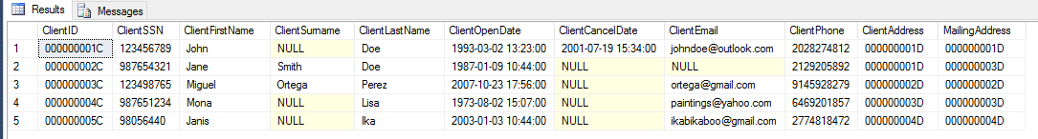

SELECT * FROM Account;

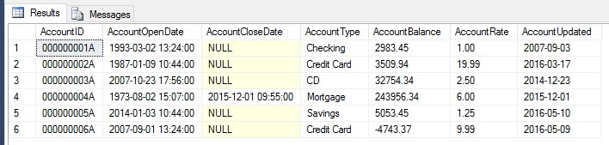

SELECT * FROM Cards;

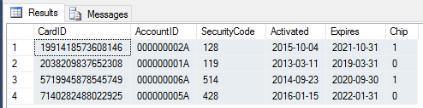

SELECT * FROM Addresses;

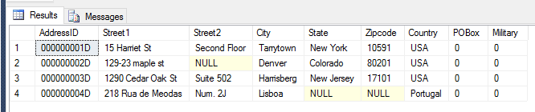

SELECT ClientID, ClientFirstName, ClientLastName,

(Street1 + IIF((Street2 IS NOT NULL), ' ' + Street2, '')

+ ', ' + City + ' ' +

IIF((State IS NOT NULL), (State + ' ' + CONVERT(varchar, Zipcode) + ', '), '')

+ Country) AS Address

FROM Client INNER JOIN ADDRESSES ON ClientAddress=AddressID

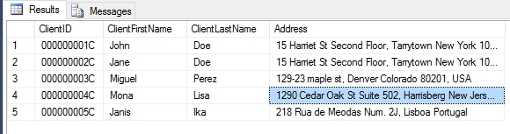

SELECT * FROM Cards, Account WHERE Cards.AccountID=Account.AccountID;

